**Rainie Yang Cheng Lin**

**Taiwanese Actress, Singer and TV Host**



Rainie Yang, has combined many roles in her career that started in 2000. She is an actress, singer as well as a television host, She was born Yang Cheng Lin in Taipei, Taiwan on the 4th of June 1984 and is widely known for her performances in at least 13 Taiwanese dramas that have made marks across the globe.



Her singing career started in a band called "4 in Love" where she acquired the stage name Raine. After the band was dissolved in 2002 she continued as a solo artiste and she broke into the world charts with the release two songs in quick succession; the 2005 *Intuition* (Ai Mei) in Mandarin Chinese and the 2006 *Meeting Love* (Yu Shang Ai).

She has also hosted many variety shows on television including the long running show, *Guess*. As an actress, her most memorable show has been *Devil Beside You* on China TV in which she played the role of a school girl, Qi Yu, infatuated with her step brother. Raine Yang is a budding star.



Within a spate of 4 years, she has been able to record 4 successful albums, starred in a film and played the lead roles in 5 dramas. Thereafter she went on to co-star in the film *Spider Lilies* with Isabella Leong in 2007. She combined working on the film with working in her usual role as a cute image in drama productions in the drama *Why Why Love* alongside Mike He and Kingone Wang. Eve then she still spared time for her music career and succeeded in recording her third album, *My Other Self* in the same year.

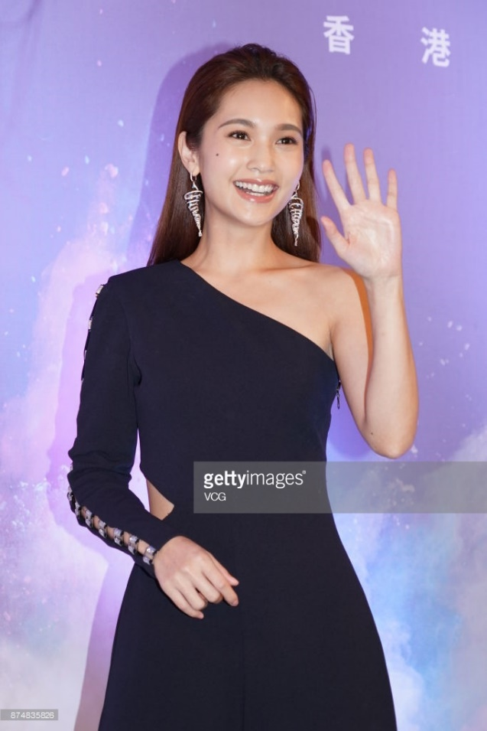

However an accident on 23 April 2008 disrupted her schedule. Raine fell down the stairs at the filming site in San Chih, Taiwan during the shooting of the Taiwanese drama *Miss No Good*. She sustained serious spinal injuries but recovered in due course to complete the assignment late in 2008. She was also able to release another album, *Not Yet a Woman*.



**After the Accident**

The next year was a bit more successful. She starred in *To Get Her* alongside George Hu and Jiro Wang. Then she filmed She was able to complete the filming of *The Child's Eye* in Thailand as well as the drama film *Hi My Sweetheart* in Taiwan. After completion of the two films she went on to record and release her fifth album, *Rainie & Love* on the first day of 2010.

Her successes did not go unnoticed in Japan and Japanese producers signed her on for the release of the Japanese version of her album *Intuition.* She also went on to release the album *Whimsical World Collection*, on 23April 2010 to the Japanese market. In the same year, she won Best Actress Award at the 45th Golden Bell Awards, for her performance in the film *Hi My Sweetheart*.



From 2011 to 2014, she starred in *Heartbeat love* (2012) the Chinese TV Drama, *Love at Second Sight* (2014) and released several albums into international charts. In 2016, she played the leading role in *Life Plan A and B* in the character of an individual known as Zheng Ruwei.

The year 2016 turned out to be one of the most successful years in her career so far. She released her 10th album which is so far the most successful album. The album, *Traces of Time in Love* was nominated for three awards at the 28th Golden Melody Awards namely Song of the Year, Best Single Producer for the title track and Best Lyricist.

The album was also nominated for in the three biggest Taiwanese entertainment awards namely Television’s Golden Bell Awards, motion pictures’ Golden Horse Awards and music industry’s Golden Melody Awards. She is truly a remarkable artiste.